**Group 2 project design**

**ER diagram**

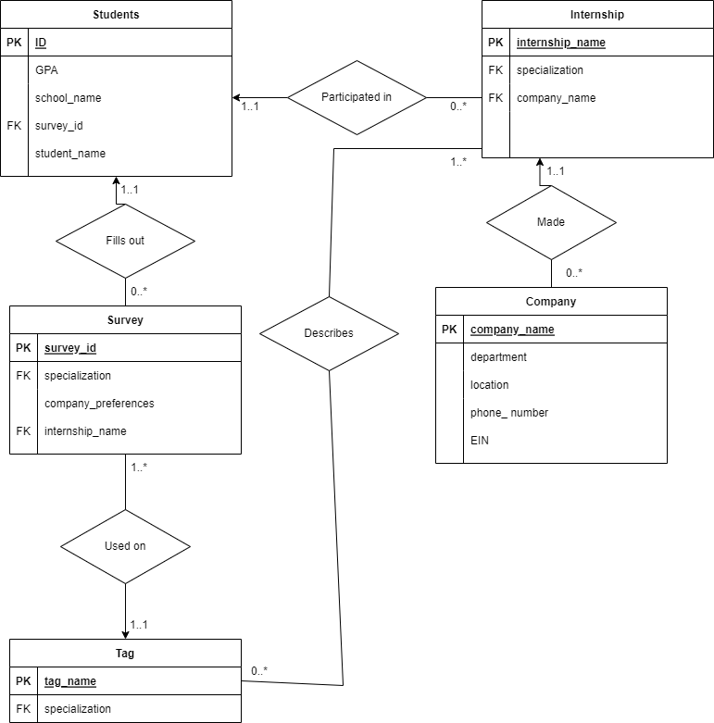

**Schema diagram**

**Create table statements**

Table students {

ID integer [primary key]

GPA integer

school_name string

survey_id integer

student_name string

}

Table survey {

survey_id integer [primary key]

speciaization string

company_preferences string

intership_name string

}

Table tag {

tag_name string [primary key]

speciaization string

}

Table company {

company_name string [primary key]

department string

location string

phone_number integer

EIN integer

}

Table intership {

intership_name string [primary key]

speciaization string

company_name string

}

Table participated_in {

ID integer [primary key]

student_name string

intership_name string

speciaization string

}